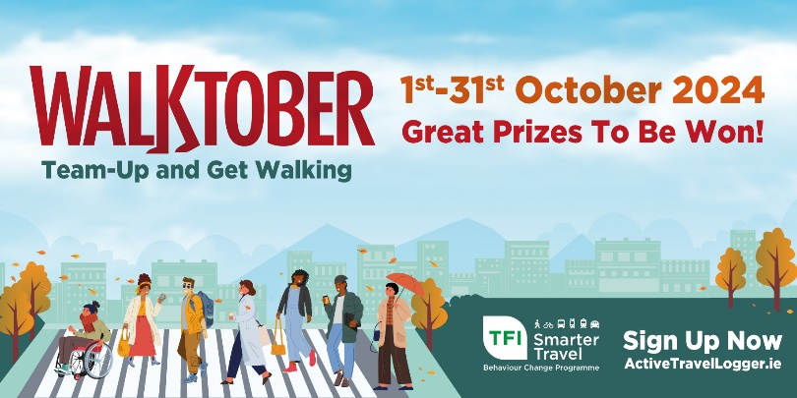

Walktober 2024 – Sample Social Media Captions

Below is a selection of social media captions you can use or amend to promote the Walktober Step Challenge to the staff and/or students at your organisation.
The sample captions can be used with the standard promotional graphics or the editable graphics available to you on www.StepChallenge.ie. If you have any questions, please do not hesitate to email stepchallenge@nationaltransport.ie.
If the character limits allow, you may wish to include the following hashtags
- #Walktober
- #TFISmarterTravel
You can tag the following page on the relevant platform.
TFI Smarter Travel Social Media
X: @TFISmartTravel
Instagram: @tfismartertravel

Announcing Walktober and the lead-in to Walktober

- #Walktober is coming!

[Organisation name] has registered to take part in the @[insert TFI Smarter Travel social media tag] Walktober Step Challenge.

To join, create your Team or join an existing Team visit www.ActiveTravelLogger.ie

- [Organisation name] has registered to take part in #Walktober.
Team-up with your colleagues and get #walking throughout the month of October. Teams must be comprised of 3 to 6 to place on the Leaderboard.
To sign up, create or join a Team visit www.ActiveTravelLogger.ie
- #Walktober is fast approaching! There are XX number of Teams signed up and ready to get #walking from [organisation name].

Staff/students who sign-up by [insert date] will go into a random prize draw to win [insert internal organisation prize]. www.ActiveTravelLogger.ie.

- Who will make it to the top of the [organisation name] Leaderboard in this year’s #Walktober Step Challenge?

- The Top [10] Teams on the [organisation name’s] Leaderboard at the end of Walktober will be entered into a prize draw to win [insert details of internal prize]. To join or create a Team visit www.ActiveTravelLogger.ie

- Get together in Teams of 3-6, create a Team on the Active Travel Logger and get ready to step👣

- Commute more sustainably, increase your activity levels and have fun as you incorporate walking throughout your day. www.ActiveTravelLogger.ie

- #Walktober is only [XX] days away. So far [insert organisation] have [XX] Teams signed up to take part.

- Log onto your Active Travel Logger account to join or create a new Team and get ready to #step. Check out the video tutorials that will help you on www.StepChallenge.ie.

- Don't forget to sign-up to take part in #Walktober. It's quick, easy and you can even do it on your mobile📱

- Walktober takes place from 1st to 31st of October with great prizes to be won throughout!👣🏆 Sign-up now: www.ActiveTravelLogger.ie

- [XX] DAYS TO GO👣 #Walktober begins on Tuesday 1st October and Team Captains are busy on the Active Travel Logger inviting their classmates and colleagues to join Teams. Sign-up now and get ready to step🕛 www.ActiveTravelLogger.ie

- [Organisation] already have [XX] number of Teams taking part in #Walktober this year. Walktober starts on Tuesday 1st October. Join or create a Team of 3-6 people and take part to be in with a chance to win great prizes! Sign-up now on www.ActiveTravelLogger.ie.

- #Walktober is a great way to connect with your [colleagues / classmates], have fun and to incorporate #walking as a mode of transport throughout your day! Sign-up now on www.ActiveTravelLogger.ie and be in with a chance to win great prizes throughout!

During Walktober 2024
Social Media throughout the challenge
Day 1 – Tuesday 1st October
- Welcome to #Walktober!👣 We hope you are looking forward to a month of stepping, fun, comradery, competitions and of course, more stepping! Don't forget to #GetWalking on the commute where possible to increase your step count! Sign-up now ➡️ www.ActiveTravelLogger.ie

Day 3 – Thursday 3rd October

- #Walktober has started! Well done to all our employees [and students] who have walked this Autumn morning! It’s not too late to take part – team-up in Teams of 3-6 and #getwalking.

Day 4 – Friday 4th October

- Take a photo while you are out walking this weekend for #Walktober and submit it into the Competition Entry Form by 2pm Monday for a chance to win a Walktober Goodie Bag for you and your Team Members.
Day 7 – Monday 7th October

- Deadline to log your steps for Week 1 of #Walktober🕛👣 Log your steps on the Active Travel Logger by 2pm today to be in with a chance to win prizes and to place on the Week 1 Leaderboard🏆 Log your steps on www.ActiveTravelLogger.ie It's still not too late to take part, sign up now!

Day 8 – Tuesday 8th October

- The #Walktober Week 1 Leaderboard is now live! Well done to everyone who has stepped alongside us during Week 1. We stepped a total of [insert number] steps👣 View the Leaderboard to see where your Team has placed within [name of Organisation] and nationally.
Day 14 – Monday 14th October
- Well done to all Team Members and Team Captains so far👏 To be in with a chance to win prizes for Week 2 of Walktober, don't miss today's deadline of 2pm. To log your steps: www.ActiveTravelLogger.ie
Day 15 – Tuesday 15th October

- The #Walktober Week 2 Leaderboard is now live! Well done to everyone who has stepped alongside us during Week 2. We stepped a total of [insert number] steps👣 View the Leaderboard to see where your Team has placed within [name of Organisation] and nationally.

Day 21 – Monday 21st October
- The deadline to log your steps is 2pm today! Log into your Active Travel Logger account and log your steps so you can place on this week’s #Walktober Leaderboard: www.ActiveTravelLogger.ie

Day 22 – Tuesday 22nd October

- The #Walktober Week 3 Leaderboard is now live! Well done to everyone who has stepped alongside us during Week 3. We stepped a total of [insert number] steps👣 View the Leaderboard to see where your Team has placed within [name of Organisation] and nationally.
Day 25 – Friday 25th October
- It’s the last weekend of #Walktober 2024 and it’s a long weekend so keep those steps going and enjoy!
Day 28 – Monday 28th October
- It’s the Bank Holiday so enjoy the day and we’re nearly at the end of #Walktober 2024 so get those final steps in before Thursday!
Day 29 – Tuesday 29th October
- The deadline to log your steps is 2pm today! Log into your Active Travel Logger account and log your steps so you can place on this week’s #Walktober Leaderboard: www.ActiveTravelLogger.ie

Day 30 – Wednesday 30th October
- The #Walktober Week 4 Leaderboard is now live! Well done to everyone who has stepped alongside us during Week 3. We stepped a total of [insert number] steps👣 View the Leaderboard to see where your Team has placed within [name of Organisation] and nationally.
Day 31 – Thursday 31st October
- FINAL DAY! #Walktober ends today and it’s Halloween so time to get spooky and step, step, step for the final time BUT remember to keep walking on your commute and wherever and whenever you can! Well done to everyone who took part!

Post Walktober 2024
Social Media post the challenge
Friday - November 1st
- Walktober is now complete. Well done everyone. Remember to log your steps before 2pm Monday 4th November and keep up walking on the commute and whenever you can.

Monday November 4th
- Walktober is now complete. Remember to log your steps before 2pm today and keep up walking on the commute and whenever you can. Final Leaderboard will be announced on Wednesday 6th November
Wednesday November 6th

- The #Walktober FINAL Leaderboard is now live! Well done to everyone who has stepped alongside us during Walktober. We stepped a total of [insert number] steps👣 View the Leaderboard to see where your Team has placed within [name of Organisation] and nationally.

