**1 Traffic Count Template Usage Guidelines**

**1.1 Background**

The NTA are currently developing a database of traffic count data. This document outlines specific guidance to deliver surveys in a compatible format. Templates for 5 different standardised formats of traffic count have been developed. These include:

1. Automatic Traffic Count (ATC)1

2. Junction Turn Count (JTC)

3. Junction Turn Count – Pedestrian Traffic (JTC - PED)

4. Vehicle Occupancy (VO)

5. Bus Occupancy (BO)

6. Bus Boarding and Alighting (B&A)

It is prudent that all guidelines outlined in this document are followed in their entirety. Importation to the new database is a highly automated process and where any guidelines are not fully observed complications, and consequently delays, during importation to the new standardised database will be experienced. For simplicity in template usage the supplied Excel Sheets have been locked – only the cells where information is required to be inputted are unrestricted.

For clarification samples are provided. It should be noted that the samples provided are for indicative purposes only and cannot be assumed to be representative of the situation on the ground at the identified location during the indicated survey period.

**1.2 Generic Guidelines**

The following are generic guidelines which need to be observed for datasets pertaining to all data types while more specific guidelines relating to each of the traffic survey types follow in Sections 1.3 through to 1.5.

Generic Guidelines:

1. Each Location surveyed will have its own MS Excel Spreadsheet.

2. Each Spreadsheet will have 4 tabs namely:

o Info o Data o Map

o Equipment

1 Where a camera setup has been used for a ‘Link Count’ style survey, the data should be inputted into an ATC

template.

It is paramount that the names of these tabs are followed exactly as is with the first letter capitalised while subsequent letters in lowercase. (Each tab will be outlined later in this section).

3. All information inputted into cells will be raw figures in their own right. They will not be linked to other cells or to other files. Such linking of cells, tabs and files causes security issues within the database.

4. All information inputted into these spreadsheets will be inserted into cells. No data or information should be inserted in text boxes.

5. The top left cell on all tabs of all MS spreadsheets will be Cell A1. No blank/empty columns or rows will be included within the datasets in the spreadsheets.

6. No cells in the data range area should be left blank. Outlined in the following section are the cases where there is no relevant value to be inserted.

7. The use of colours, text, bold, italics, symbols, etc. should be avoided within the data count fields as these will not be recognised when the data is uploaded to the database.

8. No company logos, contact details or other information pertaining to the survey company responsible for generating the dataset should be included anywhere in the file, with the exception of the company’s name included in cell A2 on the ‘Info’ tab as per the examples/templates.

9. Data should be inputted in the template in 15 minute intervals (or as specified by the contracting authority).

10. A survey does not need to be carried out for a 24 hour period for database inclusion – the attached templates’ layouts facilitate this as a maximum. In the case that a survey is carried out for 12 hours (07:00 – 19:00) then, as long as the data is placed in 15 minute intervals from the survey start time, this survey can be included. The individual Index number should start at 1 on the first line of data, and finish on the last line of data. Subsequent lines should have empty cells. A specific JTC of a 12 hour dataset has been included.

11. The streamlining of the dataset format also includes streamlining of vehicle user classes as outlined in sections 1.3 and 1.4. The specified User Classes in the templates/examples are rigid for database input. Nonetheless the data can be as disaggregated as required for the client’s needs as long as it is aggregated according to the user classes for each survey type of the NTA format. If a client specifies that buses should be stratified between operators or similar for their own dataset requirements then these should be combined into the ‘PSV’ user class for the dataset to be imported into the database.

12. Tab Detail:

**a. ‘Info’ Tab**

The Info Tab will include the following:

• Survey Company Name

• Client

• Project Reference Number

• Site Number

• Method of Survey (ATC/JTC/JTC-PED/VO/BO/B&A))

• Address (for ATCs relevant road name is adequate. For JTCs intersecting roads

should be named with a ‘/’ between each)

• GPS Co-Ordinates in BOTH Latitude/Longitude AND Easting/Northing (6- Figure).

A separate cell should be given for each of the four numbers.

• Date from (Survey Start Date)2

• Date to (Survey Finish Date)3

• Time from (Survey Start Time)

• Time to (Survey Start Time)

• Observations (Road Traffic Accidents, Strikes/Protests, Vehicle Breakdowns, Signal Failure etc.). Should there be nothing to report in this cell a ‘-‘ should be used.

• Weather (Cloudy, Raining, Snowing etc.)4

• Junction Type (Signalised, Priority, Roundabout)5

**b. ‘Data’ Tab**

The Data Tab will be where the actual survey dataset will be located. There will be an individual line of information relating to a single user class for each 15 minute interval. This individual line will include the following:

• Site Number

• An individual Index number for each line of data

• Survey date

• Survey start time (of 15 minute time interval)

• Survey end time (of 15 minute time interval)

Should it be the case that the equipment has failed (partial video errors or partial tube failures for ATC equipment during survey collection) then the results put into the data set should be a ‘-‘ rather than ‘0’.

Further detail will be required depending on the survey type. Each survey type will be expanded upon in the next section. For clarity examples supplied can also be followed.

**c. ‘Map’ Tab**

The Map Tab will feature a labelled schematic of the survey site. It will include the following:

• Client

• Project

• Site Number

• Latitude/Longitude

• Easting/Northing

• Map/Schematic of survey location

• Annotation of Arm labels (for JTC or JTC – Ped) or Directions (for ATC)

2 In the case that the survey was only carried out on one day the format should be followed with the same date in both cells

3 In the case that the survey was only carried out on one day the format should be followed with the same date in both cells

4 Regarding weather information, it is not required to give an hourly record of weather fluctuations. This section is to record EXTREME weather events (Stormy weather where fallen trees may have blocked roads,

extreme rainfall, flash floods, snowfall, icy conditions) which may alter traffic flow due to motorists avoiding unnecessary travel

5 Junction Type need only be included for JTC and JTC – Ped surveys. For ATC it should not be included

All annotation should be carried out in advance of input to the Excel file. That is once inserted to the file it should not be possible to edit the annotations/labelling. Such annotation should take place previously and a screenshot be taken and imported to the ‘Map’ tab. In the case that the annotations take place in the actual data spreadsheet, only the background Image will be imported to the database.

**d. ‘Equipment’ Tab**

The Equipment Tab will feature an image of the survey equipment. It will include the following:

• Client

• Project

• Site Number

• Latitude/Longitude

• Easting/Northing

• Jpeg Image:

o For ATC surveys a photograph of the equipment set up.

o Where cameras have been used for surveying, a screenshot of filming should be included.

**1.3 Automatic Traffic Counts (ATC)**

Automatic Traffic Count Guidelines:

1. The 6 User Classes to be used for ATC data collection are: CAR, LGV, OGV1, OGV2, PSV, M/C.

2. The data should be collected in 15 minute intervals across the survey period.

3. A count of number of vehicles per user class per direction per 15 minute time interval is

required. When no count is recorded the cell should be filled with a ‘0‘.

4. An average speed per user class per direction per 15 minute interval is also required.

When no average speed is applicable to a given user class, i.e. when no vehicles in that user class have travelled in that specific direction, an average value cannot exist and the relevant cell should be filled with a ‘–‘. The figure ‘0’ should NOT be used when no average value is applicable.

5. An overall 85th Percentile Value of all vehicles across all user classes in a 15 minute time

interval should be generated for each direction. When ten or less vehicles across all user classes have travelled in that specific direction an 85th Percentile value should not be generated and the relevant cell should be filled with a ‘–‘.

6. Arrows should be added to a site plan schematic identifying each direction of travel as per the dataset. These should be labelled ‘Northbound’ and ‘Southbound’ (or Eastbound/Westbound etc. depending on the orientation of the road being surveyed).

7. Direction labels should also be inserted into cells as per the examples to identify which is

Direction A and Direction B, and thus to relate it to the results in the Data tab.

8. A pin should be marked on a schematic/map showing the exact location that the equipment was set up. The equipment may not necessarily be the exact location specified on Request for Tender documentation as specified locations may not be

available for equipment setup due to lack of street furniture to secure it to or health and safety reasons etc.

9. Moving forward it is envisaged that a bespoke ATC scheme can be generated for the Irish market in collaboration with ATC manufacturers. In the interim however the NTA would recommend and encourage traffic count companies to use Scheme F, derived for the Federal Highway Administration in the USA. Having processed sample data through various schemes it was found that this scheme is most representative of the Irish context.

**1.4 Junction Turn Counts (JTC)**

Junction Turn Count Guidelines:

1. Typically 7 User Classes to be used for JTC data collection are: CAR, TAXI, LGV, OGV1, OGV2, PSV, M/C, P/C. Some projects may require Pedestrians to be counted at the junction also, in which case an 8th User Class (Ped) should be added.

2. The data should be collected in 15 minute intervals across the survey period.

3. Counts should be conducted with arm labelling A – F starting from the north and moving clockwise.

4. Arm labels should be located directly above each movement as a heading within the

dataset results sheet e.g. ‘A to F’.

5. Templates are set up to facilitate any number of arms up to and including 6. Where a junction doesn’t have 6 arms the non-existent movements will be labelled by ‘-1’. For example a 3-arm junction will have arms labelled A, B and C and any movements to or from D, E and F in the dataset will be identified by -1. This will result in the database receiving a matrix with a consistent and predicted number of columns (the number of rows will vary as per survey period).

6. Barred movements should be shown as such in the results by entering ‘-1’ to indicate a

false value. All barred movements should be included, paying particular attention to:

• one way arms/links approaching crossroads

• On-slips and off-slips on dumb-bell motorway junctions

• On-slips and off-slips on grade-separated motorway junctions

7. U-turn movements at all junctions will be included. U-turn movements at roundabouts

should not be assumed to be negligible and should not be marked as ‘-1’.

8. All sites should be treated as complete sites, e.g. a three arm roundabout has nine movements. If particular movements are not counted or not required by the client, this should be stated within the results as per item 5 above.

9. Separate lines of data should be completed for each vehicle class for each time period.

**1.5 Junction Turn Counts – Pedestrian Counts (JTC – PED)**

Junction Turn Count Guidelines:

1. The 5 User Classes to be used for JTC - PED data collection are: Child < 5, Child < 16, Adult, OAP and Disabled.

2. The data should be collected in 15 minute intervals across the survey period.

3. Counts should be conducted with arm labelling A – F starting from the north and moving clockwise.

4. Pedestrian movements should be captured for flows that enter an arm, exit an arm and bi- directional flows which cross an arm perpendicularly.

5. Relevant labelling should be located directly above each movement as a heading within the

dataset results sheet e.g. ‘A to F’.

6. In the case that an arm doesn’t exist (i.e. there are less than 6 arms at a junction) then a ‘- 1’

should be entered to identify this.

7. The figures for Entering Arm and Exiting Arm should be the sum of pedestrian flows on both sides of the street entering and exiting the arms respectively (see following schematic).

8. The relevant direction at each pedestrian crossing and the label of each arm should be included in a junction schematic (see Figure 1).

9. Separate lines of data should be completed for each pedestrian class for each 15 minute interval.

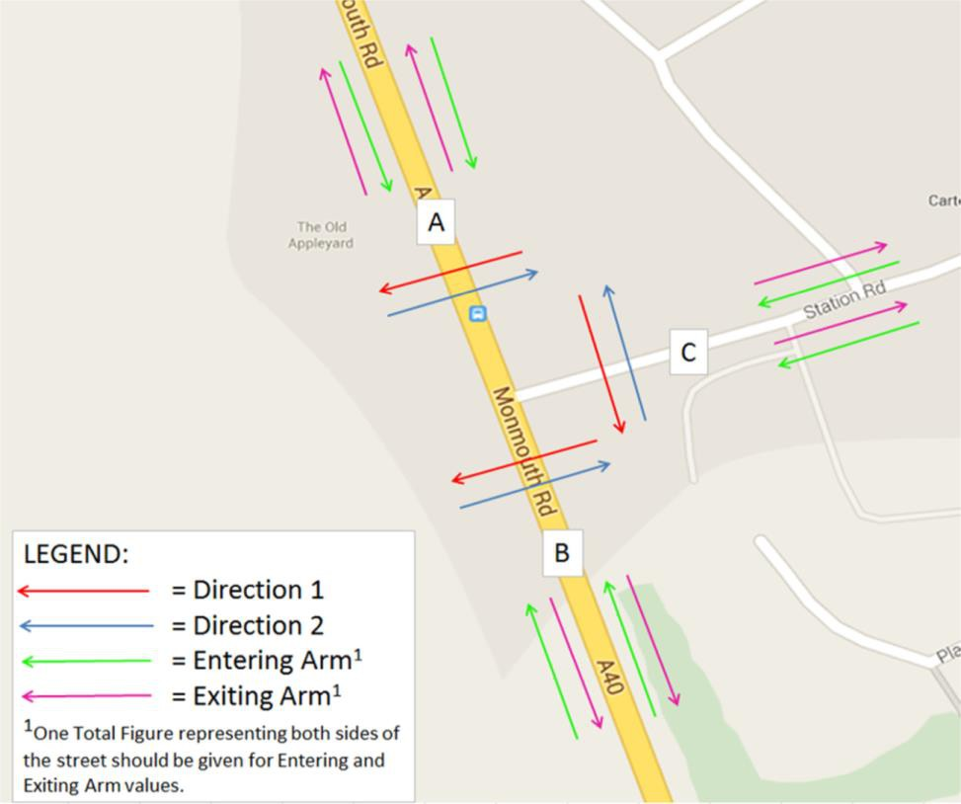

Figure 1-1: Pedestrian Survey – Junction Schematic

**1.6 Vehicle Occupancy Counts (VO)**

Vehicle Occupancy Count Guidelines:

1. The 7 User Classes to be used for VO data collection are: Occupancy 1, Occupancy 2, Occupancy 3, Occupancy 4, Occupancy 5, Occupancy 6, and Occupancy 7.

2. The data should be collected and tabulated in hourly intervals across the survey period using the occupancy categories to record the number of cars with an occupancy of 1, 2,

3, 4, 5, 6, or 7.

3. Separate lines of data should be completed for each vehicle occupancy count for each time period.

4. Separate tables should be used to display vehicle occupancy for each vehicle. For example, occupancy counts for cars should be displayed in separate table to taxi occupancy counts.

5. Where the VO counts are carried out in conjunction with JTC or ATC counts, the total number of vehicles on the road during each hourly period should also be tabulated in the excel spreadsheet.

6. In addition to a breakdown of occupancy by number of people in a car, please also give a total per time period.

7. Please note that all counts should be inclusive of the driver. For example if there is a driver and a front seat passenger in a vehicle, this will amount to an Occupancy of 2 people. Please include this explanation in the spreadsheet.

8. An overall percentage of vehicle occupancy captured should be noted by using the total number of vehicles captured in an ATC/LINK/JTC Count.

9. A pin should be marked on a schematic/map showing the exact location that the equipment was set up. The equipment may not necessarily be the exact location specified on Request for Tender documentation as specified locations may not be available for equipment setup due to lack of street furniture to secure it to or health and safety reasons etc.

**1.7 Bus Occupancy (BO)/ Boarding and Alighting (B&A)**

Bus Occupancy Count Guidelines:

1. The categories/classifications to be used for bus occupancy counts are:

a. Operator

b. Type of service

c. Registration number d. Fleet number

e. Route number f. Arrival time

g. Departure time

h. Number of passengers alighting i. Number of passengers boarding

j. Number of passengers on bus at departure or passing

k. Number of passengers left at bus stop l. Did the bus stop or pass by?

m. Direction of travel n. Bus Type

2. The data should be collected for every bus that stops at the stop or passes by the stop.

3. In the case that not all data has been captured for a bus, enter all data that was recorded, and fill the rest of the columns with n/a.

4. The relevant direction of the bus should be recorded e.g. inbound or outbound/ Direction A or Direction B. This must be annotated on an accompanying map which indicates the location where the bus survey was carried out.

5. Separate lines of data should be completed for each bus.

6. The full name of the operator should be used. E.g. in the case of Bus Eireann, the full operator name should be used, and not just ‘BE’.

7. Registration plates should be complete and checked to ensure they are in the correct format.

8. The classifications for bus type are as follows:

a. Double Decker b. Single Decker

c. Single Deck Coach d. Double Deck Coach e. Midi Coach

f. Mini Bus

9. The type of service that should be recorded is a. Public Service Vehicle

b. Private

c. School Bus

d. In the case that other service types exist, please record these.

10. Occupancy of buses should also be recorded where specified and should be categorized as follows

a. 0% occupancy (empty)

b. 25% occupancy (small number of people on board)

c. 50% occupancy (bus is half full)

d. 75% occupancy (all seats filled)

e. 100% occupancy (all seats filled and standing space occupied)

11. Arrival time and departure time should be noted down to the second (hh:mm:ss), the same value should not be recorded for arrival and departure.

12. Passengers boarding and alighting should be populated using numbers from 0 onwards, however if the passengers could not be recorded due to the bus passing by, please use a dash (‘-‘).

13. An accompanying map should be provided which shows the location where the survey was undertaken, and that also indicates Direction A and Direction B.