Project Completion Report

[ Project Title ]
[ Project Code ]
[ Investment Stream Please choose one from Heavy Rail Safety and Development, Light Rail, Bus Programme, Ticketing & Technology / Integration and Support, Accessibility, Park & Ride, Active Travel ]

NTA Project Approval Guidelines Phase 7a Deliverable

Prepared for [ Sponsoring Agency ]
Prepared by [ Preparer/Consultant ]

Date:

Quality Assurance
Deliverable prepared using NTA PCR Template v1.0
Prepared by | Checked by | Verified by | Approved by
[Insert Name] | [Insert Name] | [Insert Name] | [Insert Name]

Revision History
Revision | Revision Date | Description |  | Name | Approved by
V.0 | [dd-mm-yyyy] | [Describe changes] |  | [Insert name] | [Insert name]

References
Infrastructure Guidelines (available at https://www.gov.ie/en/collection/e8040-infrastructure-guidelines/)
Transport Appraisal Framework Module 9 – Project Implementation, Review and Ex-Post Evaluation (available at https://www.gov.ie/en/publication/c9038-transport-appraisal-framework-taf/)
NTA Project Approval Guidelines 2024 (available at https://www.nationaltransport.ie/publications/project-approval-guidelines/)
NTA Guidance on Planning for and Undertaking the Post Completion Review and Benefits Realisation Phase v1.0

Table of Contents
1. Summary of Project Information 1
2. Relevant Metrics 1
3. Project Background 2
4. Project Objectives 3
5. Project Planning Stage Summary 3
6. Total Scheme Costs including VAT 3
7. Design Summary 3
8. Outstanding Work 3
9. Tender and Construction Summary 3
10. Details of Safety File Handover and As-Built Drawings 4
11. Project Outcomes 4
12. Conclusions and Lessons Learned 4
13. Before Photographs 4
14. Completed Scheme Photographs 4
Appendix 5

Please add content for Figures and Tables here.

Summary of Project Information
ITEM | DESCRIPTION
Project Name
Local Authority
NTA Project Reference Number
Project Details
Planning Approvals Required
Designed by
Constructed by
Date of substantial completion
NTA % of Funding
Final Cost of Scheme | Year Drawdown by year end (€)  Pre 2020  2021  2022  2023  TOTAL

Relevant Metrics
If this is not an active travel project please replace with relevant metrics.
Group | Type |  | Measure | Total
PEDESTRIAN FACILITIES | 1. Pedestrianised Street | m | Centreline
 | 2. Footpath Upgrade or Improvement | m | both sides
 | 3. New Footpath | m | both sides
PED AND CYCLE FACILITIES | 4. Shared Use Ped Cycle Adjacent to Carriageway e.g. along busy inter-urban where pedestrian flows are low | m | both sides
 | 5. Urban Greenway | m | centreline
 | 6. Traffic Free Link e.g. traffic free streets, through parks and permeability links | m | centreline
CYCLE FACILITIES | 7. Segregated Standard or Stepped Cycle Track (Segregated cycle facilities that are separated from vehicular traffic by a kerb (full  height kerb = standard, 60mm kerb = stepped). A buffer may be located between the carriageway and cycle track.) | m | both sides
 | 8. 2 Segregated Standard or Stepped Cycle Track | m | centreline
 | 9. Protected Cycle Lane  At-grade (carriageway level) cycle facilities that are physically separated from vehicular traffic. Separation is typically achieved via light segregation devices e.g. bollards, planters or modular units, or achieved by locating cycle lanes behind parking bays. | m | both sides
 | 10. 2-Way Protected Cycle Lane | m | centreline
 | 11. Quietway/Mixed Traffic Street  signed routes where cyclists share the carriageway with vehicular traffic. Only suitable for roads with low traffic  speeds and volumes such as quiet residential or access streets | m | centreline
 | 12. Mandatory Cycle Lane | m | both sides
BRIGDES | 13. New Pedestrian Bridge | no: | centreline
 | 14. New Pedestrian and Cycle bridge | no: | centreline
BUS | 15. New Bus Lane | m | both sides
ASSET RENEWAL | 16. Bus Lane Resurface | m | both sides
 | 17. Cycle Lane Resurface | m | both sides
 | 18. Traffic Calming | m | centreline
FEATURES | 19. Junction upgrade | no:
 | 20. Side Road Junctions upgrade | no:
 | 21. Isolated ped or zebra crossing | no:
 | 22. School Zones - Line-marking stating ‘School Zone’ ,road surface treatment road demarcating the front of school area, may also include pencil-shaped bollards | no:
 | 23.School Streets - traffic free during drop off and collection times | no:
 | 24. Modal Filter | no:
 | 25. Cycle Parking Stands (One Stand holds 2 bikes) | no:
 | 26. Bus Stop | no:
 | 27. Island Bus Stop | no:
Other | Please state

Project Background
Please provide a summary of the intervention, project background and the rationale for intervention.

Project Objectives
Please describe/list the objectives of the project.

Project Planning Stage Summary
Review the project documentation, including final business case, assessing:
- whether the need for intervention was correctly identified
- if the strategic and policy alignment was still valid throughout the various project phases and if it is still valid at project completed
- the suitability of project assumptions
- the effectiveness of scenario analysis in anticipating changes to project conditions (for example the counterfactual, and the project completion scenario including other concurrent projects)
- the appropriateness of the KPIs identified for measuring performance to date
- compliance with guidance (Infrastructure Guidelines, Transport Appraisal Framework, Project Approval Guidelines) .

Total Scheme Costs including VAT
PROJECTED COST SUMMARY: | ESTIMATED COST | ACTUAL COST
Design/Planning
Construction/Implementation
Construction/Implementation Supervision
Land/Property Acquisition
Other Costs – Various surveys (topo/geotechnical/utilities etc)
TOTAL
Summary of differences between estimated and actual costs

Please provide details of contingency and risk funds utilisation and key lessons from the project in the control and possibly limiting the utilisation of those.

Design Summary
Include any challenging/interesting/non-standard elements and highlight changes to the scope set out in the Detailed Business Case (or Detailed Project Brief). Were statutory requirements complied with and design requirements met?

Outstanding Work
Please identify any outstanding work (if applicable).

Tender and Construction Summary
The following should be discussed:
- Whether or not the procurement strategy was appropriate and what could have been procured differently
- Effectiveness of contract management, including dispute management and whether all contract obligations were met
- Alignment with milestones as set out in the Project Execution Plan
- Effectiveness of governance and management structures
- Effectiveness of project cost control
- Effectiveness of risk identification and management
- Major changes agreed at construction stage
- Contingency fund management and utilisation
- Risk fund utilization and key changes
Feedback from contractors and project management team should be included.

Details of Safety File Handover and As-Built Drawings

Project Outcomes
Discuss the outcomes of the project, including how they compare against the initial project objectives, and the initial benefits of the project. Include summary details of any pre/post implementation surveys and/or traffic counts conducted and stakeholder/user feedback available.

Conclusions and Lessons Learned
Provide details of lessons learned from the scheme which may benefit future schemes, i.e. aspects of the Contract which worked well, which did not work well, or which could be changed or improved, and any lessons learned from contractual claims,

Before Photographs
Please insert images of the site prior to construction works commencing.

Completed Scheme Photographs
Please insert good quality images of all major elements of the completed scheme.
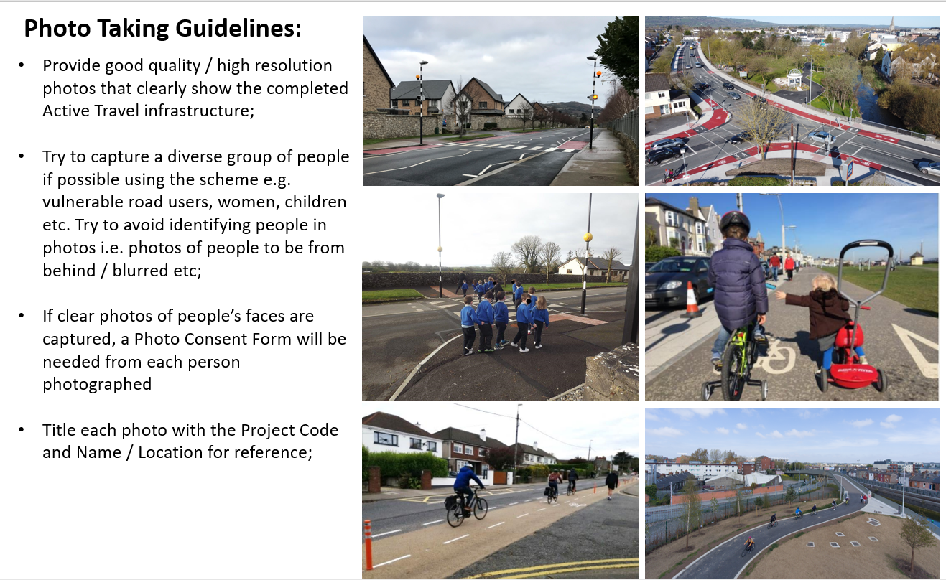

Appendix
Relevant documents can be attached here.

