**LAUNCH EMAIL**

This is an **example text** that can be used to email all staff and students and to provide information on student and staff pages of your website –and anywhere else that might be relevant for your workplace or campus!

**Subject line:** Announcing the Ready, Set, Cycle campaign!

**Email text:**

Ready, Set, Cycle: April 28th to May 25th

We are delighted to announce that we are taking part in the Ready, Set, Cycle programme. This programme is aimed at getting you ready and set to cycle! There will also be the chance to win some great prizes along the way.

Whether you are interested in cycling for the first time, or want to get back on the bike, this programme will provide you with the tools to do just that.

On April 29th The Smarter Travel Programme are holding a Cycling Skills, Cycle to Work Scheme, and Cycle Challenge. Please sign up to the webinar here (spaces are limited):

[Register for the cycling webinar](https://nta.qualtrics.com/jfe/form/SV_2ctbJMbeW4TI3qe)

Cycling Challenge: May 5th – May 25th

We are taking part in a journey logging challenge on the Active Travel Logger from May 5th to May 25th

**How to take part**

1. Get into a team of 2 – 4 people
2. Sign-up online at [www.activetravellogger.ie](http://www.activetravellogger.ie)
   1. Team Captain: choose a team name and set your team up on the Active Travel Logger
   2. Team Members: sign up online at Active Travel Logger and join a Team.
3. For help getting started, please read the **Participant Guide** attached to this email and view the step-by-step **Active Travel Logger video tutorials** on cyclechallenge.ie

**If having an in-house try a bike day**

**Email text:**

Calling all new cyclists!

We are delighted to be running a “Try a Bike day” on [Add date here]

This event is designed to encourage more people to consider cycling as a form of active transport.

During the try a bike day, you will have the opportunity to test a range of bicycles and learn more about the benefits of cycling. [If applicable] There will also be an expert on hand to answer any questions you might have!

Kind regards,

[Name]

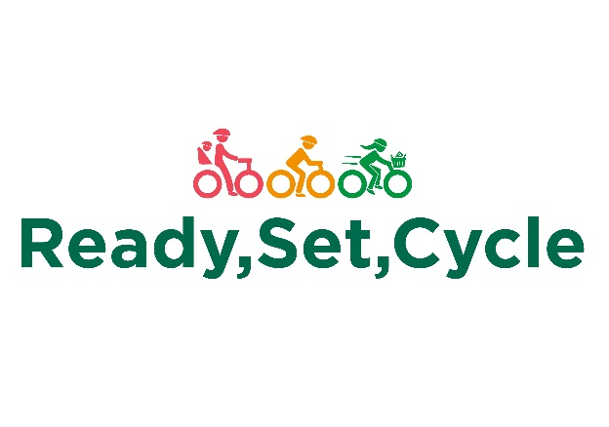

**SAMPLE EMAIL – CYCLE TO WORK SCHEME**

Dear [Staff Member],

As part of the Ready, Set, Cycle programme, we are excited to promote and encourage you to sign up for the Cycle to Work scheme! This scheme allows you to save money on a brand new bike and cycling equipment while also improving your health and wellbeing.

By signing up for the scheme, you can get up to 52% off the cost of a new bike and equipment, making it an affordable way to get active and reduce your carbon footprint. You can choose from a wide range of bikes, including road bikes, hybrids, and e-bikes, and you can spread the cost over a year through salary sacrifice.

To sign up, [Insert internal resource on how to sign up here]. You can then choose your bike and equipment and submit your application to us for approval. Once approved, you can start enjoying the benefits of cycling to work!

We strongly encourage all our staff members to take advantage of this fantastic scheme, whether you're a seasoned cyclist or a complete beginner. Cycling is a great way to improve your physical and mental health, reduce your stress levels, and save money on commuting costs.

If you have any questions about the Cycle to Work Scheme, please do not hesitate to contact us [insert contact details]. We are here to support you and help you get the most out of this exciting opportunity.

Best regards,

[Your Name]